Project Proposal on

**F*inancing* Management S*ystem***

**Suman Shahi**

*00174381*

Computing Project

Level 5 Diploma in Computing

Softwarica College of IT & E-Commerce

Kathmandu, Nepal

Submitted to

Niman Maharjan



# 2.1 Introduction to analysis

Analysis is the process of examining all detailed component of the system in the project. First of all, analysis studies on the problem study, feasibility study and requirement studies rather than solving issues. It is the connection between the information we have and the system that should actually work. It focuses on the to build the understanding of the system and helps to remove the problems that occur during the system development. Problem solving technique is applied to this project for improving the system and to identify the component of system to finalized the project. A detailed study of the process must be made by various techniques like interviews, questionnaires etc.

Upcoming project, close study and problem areas are identified as it is providing an overview of the project and steps to complete the project level. Time is estimated in order to complete the project with designate budget and its functional and non-functional requirements. Each phase dedicates the progress of project development through design phase, development phase etc.

# 2.2 Rich Picture

It is a detail pictorial presentation through analyze and understand the whole system through rich picture for clients and developers. Rich picture is sketch in a paper by hand that includes system development, process and structure. For Rich Picture there is no specific rules and guidelines.

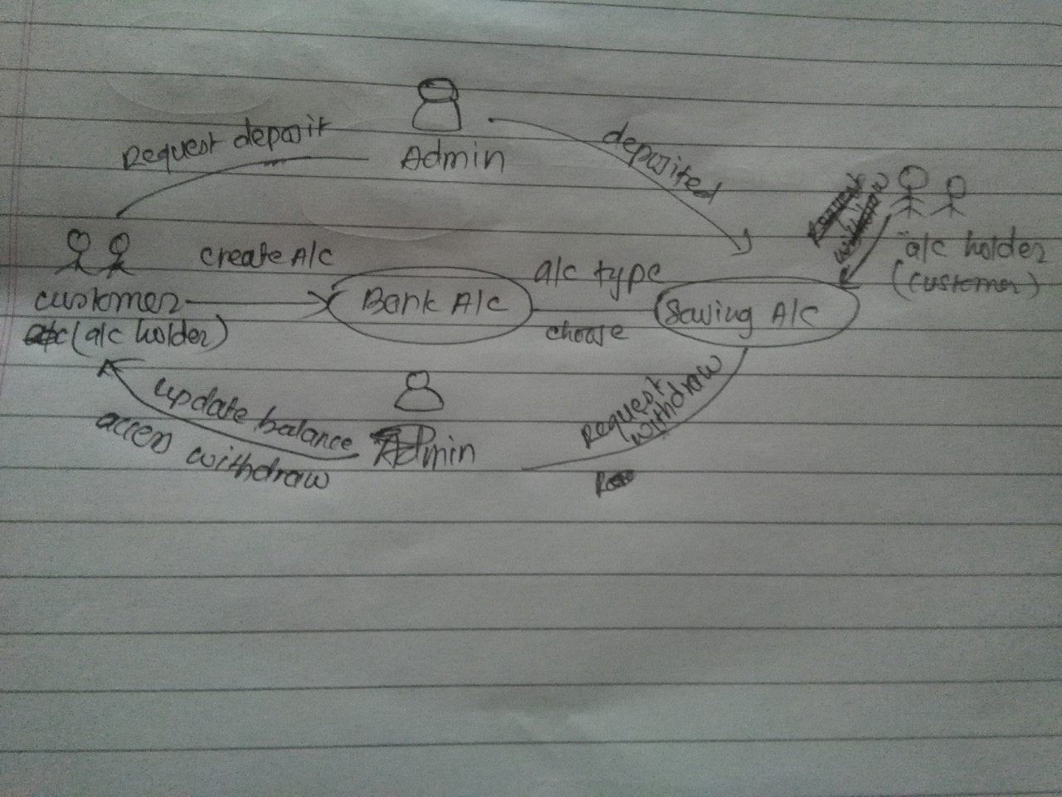

Fig: Rich Picture

# 2.3 CATWOE analysis

I have used CATWOE for my project, that helps to identify users need to be taken into account in order to enhance productivity and quality assurance.

CATWOE refers to the SSM **“Soft System Methodology”** for Analysing Information Systems is a more people focused analysis rather than using hard approach. Analysing the human activity is soft system.

In project, CATWOE analysis helps to identify and categories all the people, process and external factors involved in the information system.

CATWOE allows to know

Who are the customers of our system?

Who are the users of the system?

What is transformed by the system?

Who owns, controls and pays for the system?

What is the overall view of the system?

What are the economic, social, political, technical and environmental constraints to the system?

These questions provide the analysis to give idea about to use suitable methodology for specific case but doesn’t provide any solution to the problem. It allows us to understand easily, easy to communicate among user, analyst, designer and programmer.

**Customers:** Account holders are stakeholders that exits in finance system. Customers are those who benefit or do not benefit when the system or process changes. It’s a first step for identifying such customers and understanding how the process or system affects them.

**Actor:** Actor are directly involved with the system for implementing the changes, probably to staffs or employees. Through actor we can get the solution from there point of view from the problem faced of the system. Well actors are the admin of the system.

**Transformation:** Transformation is the change to what happens to the system or data and what processes will be affected by the development of the system. It describes the inputs and nature change such inputs undergo to become outputs from the system through customers. Change of money transaction and its profit and loss can be affected in the business. For better performance client who is using the application should be guided in easy way for using it, should be fast and reliable. For statements and account details, customer need to go for bank which is non time manageable so it makes hard for both stakeholders and customers to do up and down. Now the problem can be solved through this application we customer don’t need to go bank for their profile detail of bank.

**Worldview:** it is most crucial as different stakeholders have different ideas and approaches with same issues. It is a justification of what is going on and outside the organization for the transformation of the system. It comes up with the positive and negative impact on the overall organization. It analyzes the real problem on the system and give solution from different suggestion for particular problem. Not only one solution can be seen or used there are many solutions for one problem from different views of people. This element ensures to clear the understanding of the system.

**Owner:** Owner is who owns the organization and have power to control and make decision over a system. Its their decision to make whether the system will be implemented or not. In this organization system is the admin user of organization who has the authority and responsibility to control how to lead the whole system to solve problem, if any problem is suffered project is stopped, and change is done whether to run the project in future of not. Owner is the changer of system. Investigator investigates analysis and development of system for solving problem.

**Environment:** Most of the problem are arise through awareness of the demands of political, legal, economic, social, demographic, technological, ethical, competitive and environmental factors and their associated constraints and limitations under which the system works, and which may hamper the system change. It needs to be investigated whether this will affect the analysis and development of the system. Most of the problem arises through the server failure where customers can get updated statement in their profile. System works under the external constraints which may hamper the changes to the system.

2.4 FEASIBILITY STUDY  
Feasibility study is made to see if the project on completion will serve the purpose of  
the organization for the amount of work, effort and the time that spend on it. Feasibility  
study lets the developer foresee the future of the project and the usefulness. Its main objective is not to solve the problem, but to acquire its scope. A feasibility study of a system proposal is according to its workability, which is the impact on the organization, ability to meet their user needs and effective use of resources. Thus, when a new application is proposed it normally goes through a feasibility study before it is approved for development. The document provides the feasibility of the project that is being designed and lists various areas that were considered very carefully during the feasibility study of this project such as Technical, Economic, Behavioral and Operational feasibilities. The following are its features:

2.4.1 TECHNICAL FEASIBILITY  
The system must be evaluated from the technical point of view first. The assessment  
of this feasibility must be based on an outline design of the system requirement in the  
terms of input, output, programs and procedures. Having identified an outline system, the investigation must go on to suggest the type of equipment, required method developing the system, of running the system once it has been designed.  
Technical issues raised during the investigation are:  
*Does the existing technology sufficient for the suggested one?  
Can the system expand if developed?*  
The project should be developed such that the necessary functions and performance  
are achieved within the constraints. The project is developed within latest technology.  
Through the technology may become obsolete after some period of time, due to the fact  
that never version of same software supports older versions, the system may still be used.  
So there are minimal constraints involved with this project. The system has been  
developed using Java the project is technically feasible for development.

2.4.2 ECONOMIC FEASIBILITY  
The developing system must be justified by cost and benefit. Criteria to ensure that  
effort is concentrated on project, which will give best, return at the earliest. One of the  
factors, which affect the development of a new system, is the cost it would require.  
The following are some of the important financial questions asked during preliminary  
investigation:  
• The costs conduct a full system investigation.  
• The cost of the hardware and software.  
• The benefits in the form of reduced costs or fewer costly errors.  
Since the system is developed as part of project work, there is no manual cost to spend  
for the proposed system. Also, all the resources are already available, it gives an indication of the system is economically possible for development.

2.4.3 BEHAVIORAL FEASIBILITY  
This includes the following questions:  
*Is there sufficient support for the users?  
Will the proposed system cause harm?*  
The project would be beneficial because it satisfies the objectives when developed and  
installed. All behavioral aspects are considered carefully and conclude that the project is  
behaviorally feasible.

## 2.4.4 OPERATIONAL FEASIBILITY

Issues to be studied are, is there sufficient support for management and users? Is the current method acceptable to users? Will the proposed system cause any harm? This billing software is operationally feasible. This application provides the necessary information to the user such as how to enter the information regarding different operations performed on the database. The application was planned in such a way that no prior knowledge was required to go through the various operations. The user just needed to have the basic knowledge of computers. This software also possesses behavioral feasibility. It’s because the users of the system are computer professionals and know the advantages of computer system. Moreover, this application is going to enhance their skills and reduce their workloads.

## 2.4.5 LEGAL FEASIBILITY

There is a set of rules for the organization provide under the law of government. We cannot get out of the boundary that is illegal for our organization.

## 2.5 Requirements

Requirements analysis is done for the purpose of gathering information about the functions required in the system. It helps to clear the main purpose of a system. It is normally the first step in a development process. It breaks down the requirements into functional and non-functional categories for better understanding.

If the requirements of the project are not collected properly then there is high chance of the project failing. The requirements keep on changing as the system get developed which can be a merit or demerit to the project. We need to do the requirements analysis to figure out the client’s expectations with the product. There are a number of ways to gather the requirements such as surveys, focus groups, questionnaires, observations, etc. In this project, the requirements were collected by interviewing the stakeholders, researching about the system, and documentation.

### 2.5.1 Functional Requirements

|  |  |
| --- | --- |
| ID | R1 |
| Title | Signup for User |
| Description | Providing the required details Customers are able to register |
| Rational | Storing the user detail for sign in purposes |
| Dependencies | R2 |

|  |  |
| --- | --- |
| ID | R2 |
| Title | User Login |
| Description | Clients Sign In through their existing details otherwise error message will be displayed if account details are incorrect |
| Rational | Preventing unwanted users sign in |
| Dependencies | R1 |

|  |  |
| --- | --- |
| ID | R3 |
| Title | Searching Customer |
| Description | Admin are able to search account holder customers |
| Rational | To show details about customer |
| Dependencies | N/A |

|  |  |
| --- | --- |
| ID | R4 |
| Title | Viewing the details of account holder |
| Description | Admin and Customers should be able to view details of customer |
| Rational | Maintaining the accuracy of customer details |
| Dependencies | R1 |

|  |  |
| --- | --- |
| ID | R5 |
| Title | Editing the details of account holders |
| Description | Admin and Customers are able to edit customer account details |
| Rational | Maintaining accuracy and security of customer details |
| Dependencies | R1 |

|  |  |
| --- | --- |
| ID | R6 |
| Title | Deleting Registered Customers |
| Description | Registered Customers are deleted by the Admin |
| Rational | Maintaining details accuracy |
| Dependencies | R1 |

|  |  |
| --- | --- |
| ID | R7 |
| Title | Interest Calculating |
| Description | Interest are calculated by the admin by user’s balance |
| Rational | Providing the statement of the balance |
| Dependencies | R8 and R9 |

|  |  |
| --- | --- |
| ID | R8 |
| Title | Adding Balance |
| Description | Customer balance is added by the admin |
| Rational | Updating the balance |
| Dependencies | N/A |

|  |  |
| --- | --- |
| ID | R9 |
| Title | Balance Deducting |
| Description | Customer balance is deducted by the admin |
| Rational | Updating the balance |
| Dependencies | N/A |

|  |  |
| --- | --- |
| ID | R10 |
| Title | Sing out |
| Description | Customer and Admin logout form the system |
| Rational | Making safe and secure |
| Dependencies | R1 and R2 |

### 

### 2.5.2 Non-functional requirements

|  |  |
| --- | --- |
| ID | N1 |
| Title | Availability |
| Description | Disabled people should be able to use the website |
| Rational | Spreading the website to rise |
| Dependencies | N/A |

|  |  |
| --- | --- |
| ID | N2 |
| Title | Backup |
| Description | For data loss data backup should be provided securely |
| Rational | Maintain data authenticity |
| Dependencies | N/A |

|  |  |
| --- | --- |
| ID | N3 |
| Title | Security |
| Description | All important data should be encrypted |
| Rational | Maintain the user privacy |
| Dependencies | R1, R2 |

|  |  |
| --- | --- |
| ID | N4 |
| Title | Reliability |
| Description | For the accurate transaction in the system the system should be reliable |
| Rational | Without any problem retrieving the information |
| Dependencies | N/A |

### 

# 2.5.3 SRS

It stands for software requirement specification which describes all of the functions of a proposed system and the constraints under which it must operate.

**Hardware Requirements Specification**

Processor: Intel Pentium III or later

Main Memory (RAM): 256 MB

Cache Memory: 512 KB

Monitor: 14-inch Color Monitor

Keyboard :108 Keys

Mouse: Optical Mouse

Hard Disk :160 GB

**Software Requirements Specification**

Front End/ Language: PHP

Back End/ Database: MYSQL

Additional Tools: XAPM Server

Operating System: Windows 7, 8, 9, 10, XP

### 2.5.4 Prioritization

Prioritization helps to distinguish the importance of a feature. Without it a project wouldn’t be good in quality. It helps in maintaining a level of quality which the user defines, by completing the user requirements according to their ranking. It helps in understanding the user requirements and in fulfilling them in time. While there are various prioritization methods available, MoSCoW is the most suitable.

MoSCoW is a simple and quick prioritization method. It gives a specific result. The specific use of its keywords gives accurate solutions. It stands for:

M: Must have

S: Should have

C: Could have

W: Won’t have

The MoSCoW prioritization is done below:

|  |  |
| --- | --- |
| **Requirements** | **MoSCoW** |
| R1: User signup | Must |
| R2: User login | Must |
| R3: Search customers | Could |
| R4: View account details | Must |
| R5: Edit account details | Must |
| R6: Delete registered customer | Should |
| R7: Calculate interest | Must |
| R8: Add balance | Must |
| R9: Deduct balance | Must |
| R10: Logout | Must |
| N1: Security | Must |
| N2: Availability | Could |
| N3: Reliability | Should |
| N4: Backup | Must |

## 2.6 Use cases

Use case is a methodology used to represent the functionality of a system done in the analysis phase. In this diagram actors represented by stick figures show clients or subsystems and the actions are given in oval balloons.

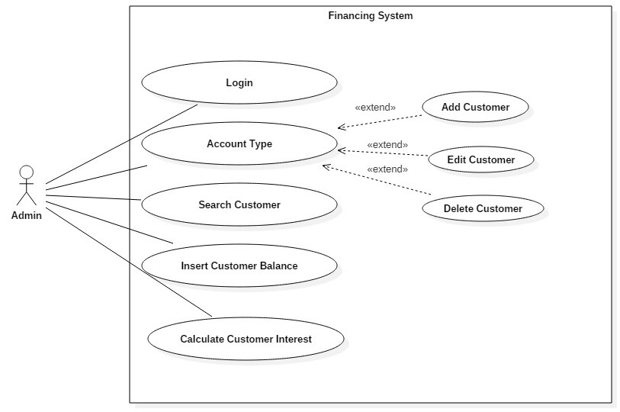

Fig: Use Case 1

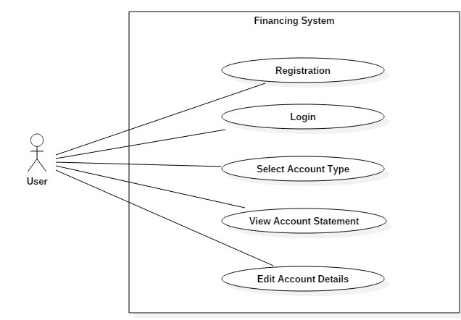

Fig: Use Case 2

|  |  |  |
| --- | --- | --- |
| **Case no.** | **Title** | **Description** |
| 1 | **Sign-up** | For sign up process user need to open website and click button for sign up |
| Sign up form is filled by user providing the details |
| Sign up button is pressed for sign up to the system |
| System validates the detail whether information is correct or not |
| Successful message is displayed after the right customer sign in in the system |
| 2 | **Login** | For login in the system admin/user goes to login page through website |
| Username and password are filled to login into the system |
| Login button is provided to login into the system |
| Details is validated whether it is correct or not to login to the system |
| Wrong details provide error msg while login into the system |
| Successful login is redirected to the system and admin/user can go to their account page |
| User/admin can view their account details and can edit them also after login it |
| 3 | **Logout** | Logout button is provided to logout from system by admin/user |
| After logout admin/user are taken to home page |
| 4 | **Add balance** | Balance is added by admin clicking add balance button |
| Required amount is added by the admin in users account by save button |
| Updated Balance is added in the database |
| 5 | **Subtract balance (when withdrawn by customer)** | Balance is deducted by admin clicking subtract button |
| Required amount is kept in form by admin clicking save button |
| Inserted balance is subtracted in database |

# 2.6 NLA

**Scenario**

Bank Account Management System keeps the day by day tally record as a complete banking system. It can keep the information of users and their Account type, account opening form, Deposit fund, Withdrawal, and Searching the transaction, Transaction reports, Individual account opening form, Group Account. The existing part of this project is; it displays Transaction reports, Statistical Summary of Account type and Interest Information.

Organization have decided to give access to their own profile and users can register, add, edit, delete account and they can see at their statement to make sure the organization is corresponding in right way of their investment. It makes easy convenient which is effective in organization. Users are able to get response and can add, view from their account to their profile.

Organization has managed taking deposit from customer and checking account and saving account to individuals and business. They are facilitating money transactions such as wire transfer and cashier’s cheque, providing loans to individuals and business.

Listed nouns and verbs:

|  |  |
| --- | --- |
| **Noun** | **Verb** |
| Users | Register, add, edit, delete, view |
| Account Type | Select, view, interest |
| Response | Add, edit, delete, view |

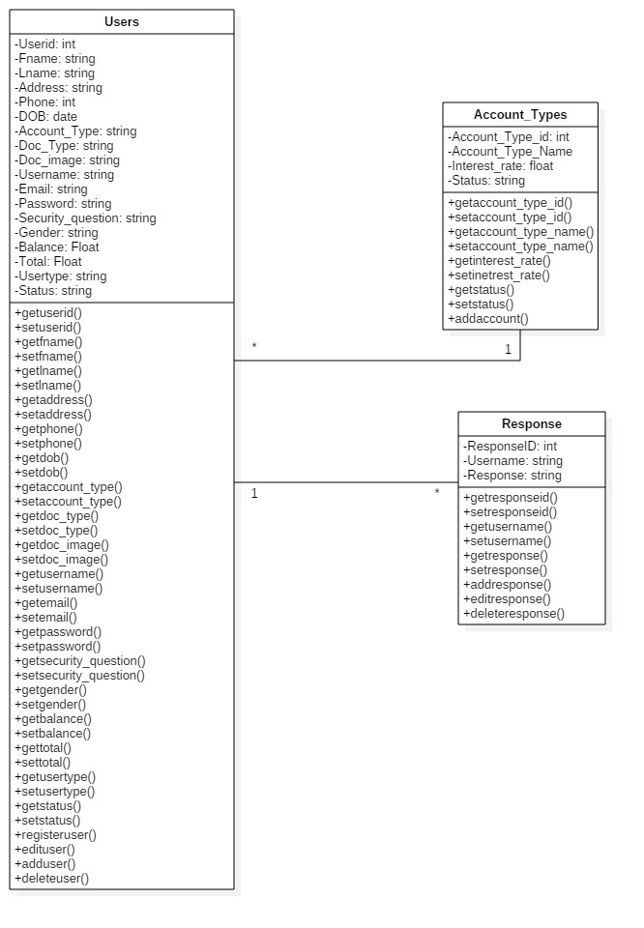

Fig: Class Diagram